

Intelligent Cryptographic Defense Framework Against Modern Ransomware Using Behavioral Analysis
COURSE: CRYPTANALYSIS AND CYBER DEFENCE (24CSB3101) A.Y. 2026 – 2027

S. No. | University ID | Name
1 | 2420030313 | Mahalakshmi
2 | 2420090007 | G. Sri Satya
Name of the Guide |  | VINISHA VELTHURU

Objectives
The primary aim of this project is to design and implement an intelligent defense framework that detects modern ransomware through behavioral analysis and neutralizes it using adaptive cryptographic countermeasures before irreversible file encryption occurs. The specific objectives are:
- To study the behavioral patterns of modern ransomware families (file I/O bursts, mass file renaming, registry modification, API call sequences and Shannon entropy changes) that distinguish malicious activity from benign processes.
- To design a real-time behavioral monitoring module capable of capturing system-level events (file access, process activity, network calls) with minimal performance overhead.
- To develop and train a machine learning / deep learning classification model that can accurately identify ransomware-like behavior from extracted features.
- To build an intelligent cryptographic defense layer that automatically triggers protective actions such as key vaulting, decoy-file deployment, process isolation and encrypted backup activation upon detection of malicious behavior.
- To minimize false positives and false negatives so that legitimate user/system operations are not disrupted while ensuring rapid ransomware containment.
- To evaluate the proposed framework using standard performance metrics (accuracy, precision, recall, F1-score, detection latency) against publicly available ransomware behavioral datasets.
- To propose a scalable, self-learning framework that updates its detection model using a feedback loop from newly logged incidents.
Flow Chart of the Project
The diagram below illustrates the end-to-end workflow of the proposed framework that is from behavioral data collection and feature extraction, through machine-learning-based detection, to the automated cryptographic defense and feedback response.
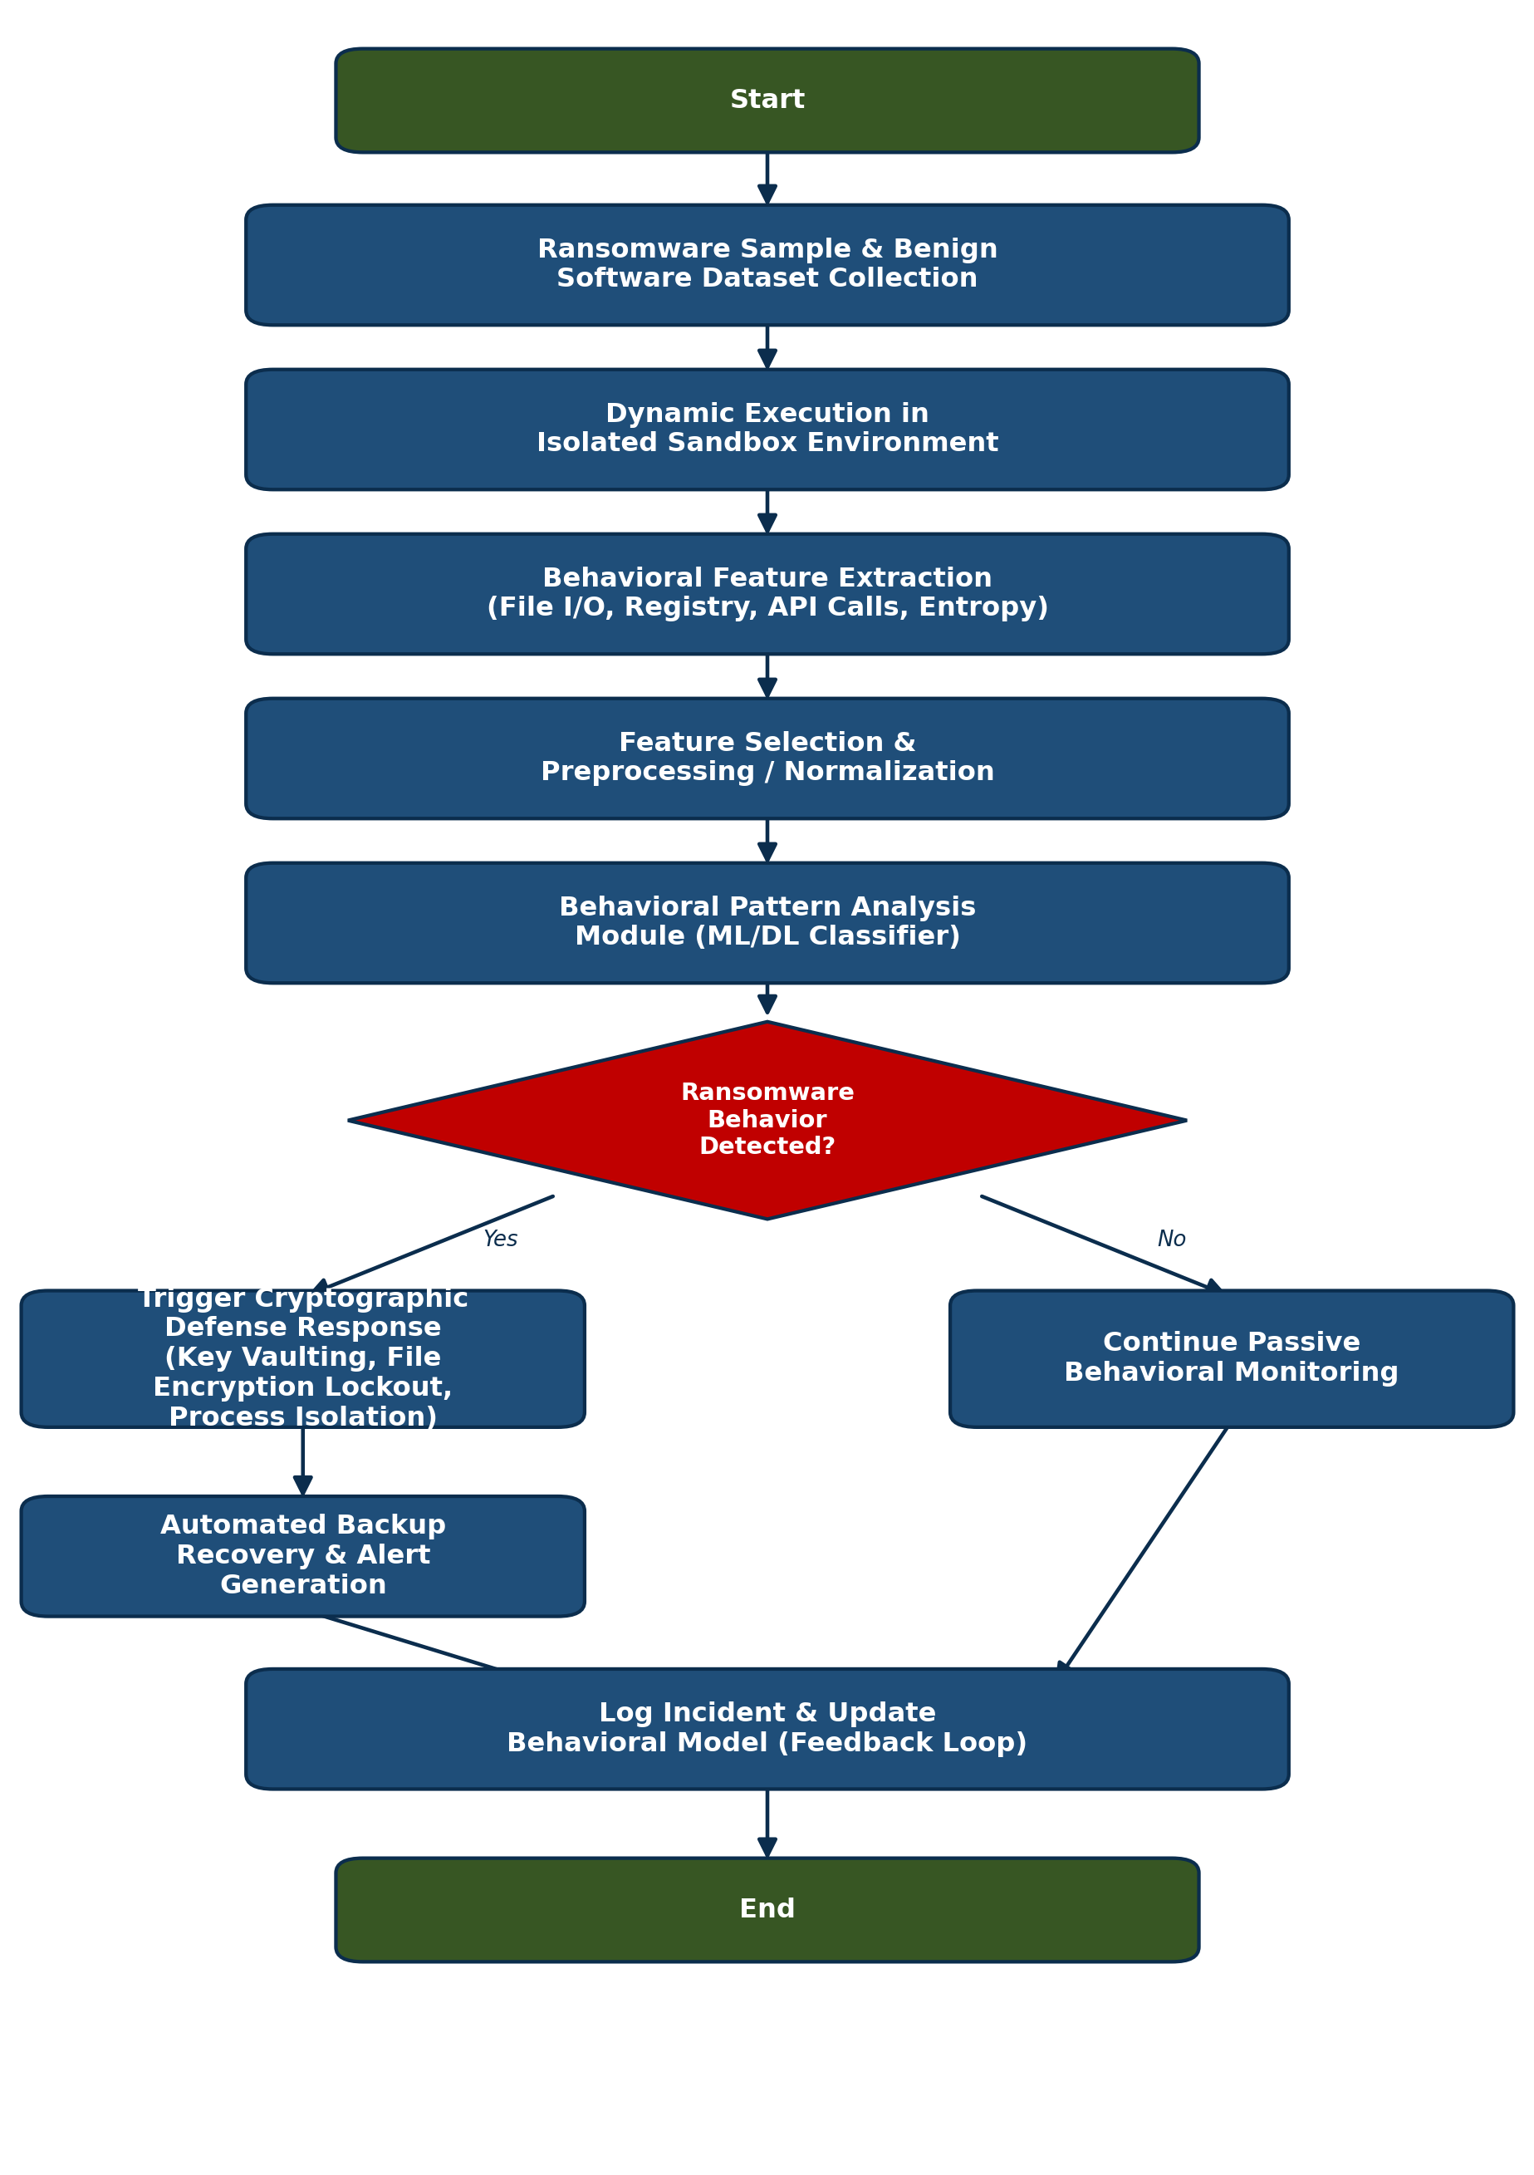

Dataset
The project will primarily use publicly available, peer-referenced ransomware behavioral datasets that provide labeled dynamic-analysis features such as file system access, storage/memory access patterns, network flow, and cryptographic indicators suitable for training and validating the behavioral detection model.
Primary Dataset: UGRansome2024
A cybersecurity dataset built for ransomware and zero-day attack analysis, containing timestamps, protocol data, network flow details, ransomware family classification (e.g., WannaCry, Locky, Cerber) and attack behavior labels suited for classification tasks.
Download link: https://www.kaggle.com/dsv/7172543
Supplementary Dataset: RanSAP / RanSMAP (Storage & Memory Access Patterns)
An open dataset of ransomware storage and memory access patterns such as I/O timing, logical block address, access size and Shannon entropy collected by executing real ransomware samples in a controlled sandbox which is well suited for the behavioral feature-extraction stage of this project.
Download link: https://www.kaggle.com/datasets/hiranomanabu/ransmap-2024-ransomware-behavioral-features
Large-Scale Dataset: MLRan
The largest open-source behavioral ransomware dataset to date, covering 64 ransomware families and 4,800+ samples with a fully open sandboxing and feature-extraction pipeline which is useful for scaling and cross-validating the trained model.
Reference link: https://arxiv.org/abs/2505.18613

Methodology Overview
1. Data Collection & Sandboxing
Ransomware samples and benign application traces are executed in an isolated virtual machine or sandbox environment. System-level activity such as file operations, registry changes, API calls, and process behavior is logged for every sample.
2. Behavioral Feature Extraction
Key behavioral indicators are extracted from the logs, including file access frequency, file rename or deletion bursts, Shannon entropy of written files which is a strong indicator of encryption, API call sequences and network communication patterns.
3. Feature Selection & Preprocessing
Extracted features are cleaned, normalized and reduced using statistical and correlation-based feature selection techniques to remove redundancy and improve model efficiency without losing detection accuracy.
4. Behavioral Classification Model
A machine learning / deep learning classifier (e.g., Random Forest, Gradient Boosting, or an LSTM-based sequence model) is trained on the labeled feature set to distinguish ransomware behavior from benign activity in near real time.
5. Intelligent Cryptographic Defense Layer
Upon positive detection, the framework triggers an automated defense response: securing encryption keys in a protected vault, isolating the offending process, deploying decoy files to intercept mass-encryption attempts and activating encrypted, versioned backups to guarantee recoverability.
6. Evaluation
The framework is evaluated on held-out data using accuracy, precision, recall, F1-score, false-positive rate and detection latency.
7. Feedback & Continuous Learning
Detected incidents and analyst feedback are logged and fed back into the model training pipeline, allowing the behavioral classifier to adapt to new and evolving ransomware strains over time.

